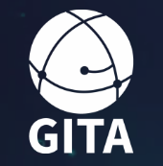
GLOBAL ICO TRANSPARENCY ALLIANCE - GITA

Questionnaire for Potential Supernodes and Nodes

- Company Name

- Registered Office Address

- Where does the company operate?

- Company URL

- Biographies and resumes of the management team

- Who are the ultimate beneficial owners? (This will be required for KYC purposes)

- When was the company incorporated?

- Where was the company incorporated?

- Please describe the company's engagement/involvement in the blockchain/crypto community.

- Please describe Crypto-specific business or primarily in the blockchain/crypto space of the company.

- Please propose how the company intends to contribute to GITA's efforts and why you want to join GITA.

- Please propose how many projects the company will commit to referring to the platform.

- Please provide any comments or suggestions for the ICO industry or GITA.

